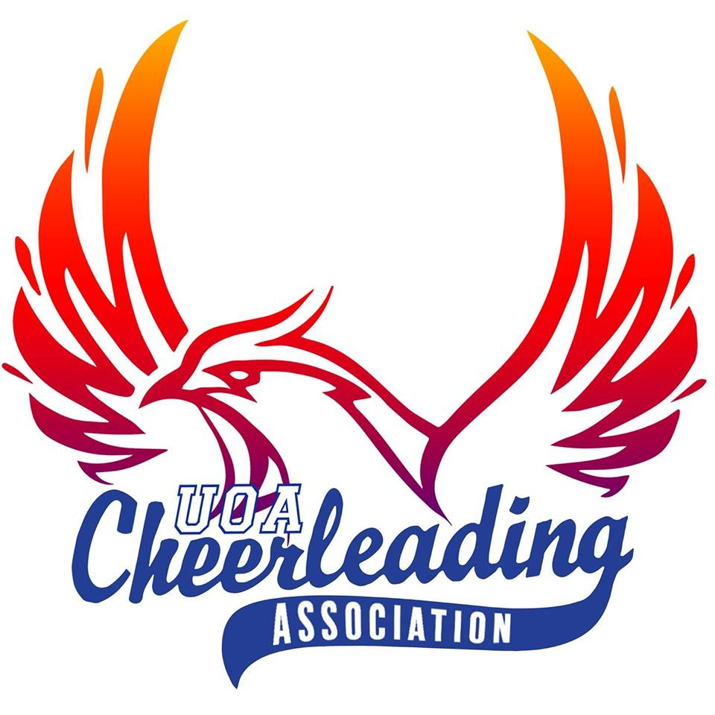
UOACA Athletes’ Code of Conduct

- GENERAL:
1.1 Spectators are not permitted to watch our trainings as it is a distraction. Prospective athletes can come to observe provided they have permission from the executive team, or coach.
1.2 A positive attitude towards all athletes, staff and executive members is expected of everyone involved in the club. Any negative attitude or actions could lead to disciplinary actions and/or termination of the association membership.
2. FEES AND PAYMENT:
2.1 Fees are due by the 24th May. If fees are not paid by 24th May a $15 late fee will be applied. If fees are not paid by the 31st May, placement on the team will be revoked and you will have to sit out of trainings until all overdue fees are paid.
2.2 Team fees are based on a per semester or annual basis, not per training basis, therefore if a training is missed, a refund will not be given for that training. However, weekly/monthly payments of fees are accepted (must be organized with the Treasurer, PRIOR to due date) as a means of paying fees in full. No payment plans can be organized after this date, nor without Treasurer consent.
2.3 If you decide to leave the team, or are unable to complete the semester with the team, you will not receive a refund for your fees and may still be required to reimburse UOACA for costs caused by your withdrawal. This includes any event (including but not limited to: competitions, performances, or travel expenses) that the athlete had been enrolled in.
2.4 If any legal action were to be taken against the association regarding any situation involving any athlete/s, then full cost of that legal action would fall onto the athlete/s involved.
3. HEALTH AND SAFETY:
3.1 Athletes must declare all medical conditions, allergies, or reoccurring injuries that could seriously affect their own, and other athletes’ wellbeing if not specified.
3.2 Athletes may not attempt cheerleading activities (such as stunting or tumbling) during training times without the coach’s supervision/permission.
3.3 The University of Auckland Cheerleading Association will not be held liable for any injury outside of or within the Association’s trainings/events, including third party events.
3.4 The athlete understands that cheerleading is a dangerous sport and must accept the potential of injury. UOACA and its staff will not ask the athlete to do anything that the coaches feel they cannot do safely and comfortably. All safety precautions will be taken to create a safe environment for the skills to be taught, learnt and practiced.
3.5 As it is a voluntary position, the athlete has the right to opt out of an activity, of a reason ground, that they deem dangerous to their health and safety, or that of others.
.
4. TRAINING:
4.1 Attendance
i Tardiness will not be tolerated. Athletes should endeavor to arrive, prepared, 15 minutes prior to the start of training.
ii Attendance at all trainings, extra-trainings, competitions and performances is mandatory. If you cannot make any association event, the coach should be informed at the earliest possible convenience with a valid reason. Invalid reasons include but are not limited to: social events, other sporting or co-curricular activity, mild/non-contagious sickness, overtired, etc.
iii Missing team events for major illness or bereavement is acceptable. Please notify your coach in the event of this.
iv If an athlete is sick or injured they are still required to attend, however, they may sit out of training and watch for changes to choreography & positioning.
v In the event that an athlete does miss a team event or training, they may be re-positioned in the routine in order to avoid further disruption to the progress of other team members.
vi If you become seriously ill and are unable to attend training for a prolonged period, the coach and the executive team have the right to ask you step down from the team if there is a concern for the team’s progression and your own health.
vii We understand that university work should always come first, however as an athlete you must manage your time effectively. Therefore, we will not tolerate consistent absence at trainings due to poor time management.

4.2 Attire and equipment
i Athletes must be changed into appropriate training gear with jewelry removed or strapped by the time training begins.
ii Only sportswear that allows for a full range of motion may be worn during training. Clothing that is restrictive or distracting to others (e.g. trip hazards, oversized).
iii All flyers must wear cheer shoes, or substitutes approved by the coaching staff.
iv We recommend that you bring a water bottle to training to keep hydrated.
4.3 Gym rules
i Personal items should be placed in the designated area or cubby holes and not on the gym floor.
ii Food and drink are allowed only in designated areas. Please no glass containers. ABSOLUTELY NO FOOD OR DRINK on the cheer floors.
iii NO GUM is allowed in the gym.
iv All athletes/participants MUST be signed into the attendance for each training. This is an OSH regulation so that we know who attends at any given time, should a disaster occur.
v UOACA is not responsible for lost or stolen items.
5. BEHAVIOUR:

5.1 Disrespectful behaviour will not be tolerated. This includes, but is not limited to the following:

i Use of inappropriate language towards another athlete, coach, parent or staff member;
ii Inappropriate comments made about or to another athlete, coach, parent or staff member;
iii Lack of cooperation or willingness to participate positively in training;
iv Bullying other athletes, coaches, staff members or individuals affiliated with UOACA either within scheduled training time or in your own time;
v Poor sportsmanship or negative comments towards competition teams whether at training, competition or in your own time.
Please note: this policy also applies to all internet or social media sites.
5.2 Physical violence or any kind of behaviour which is in violation of any governing law will result in the athlete(s) in question being asked to leave the association.
5.3 UOACA may dismiss or suspend any athlete for the following reasons (includes but is not limited to):
i Committing any act which would be considered an offence under any governing law;
ii Un-sportsmanship like attitude, actions that impact the wellbeing and progression of the team. Disrespectful behaviour towards coaches, team management, staff, any other athletes, or anyone involved with the UOACA association including but not limited to derogatory remarks, spiteful comments, bad sportsmanship behaviour, coercing team members to quit or join another program;
iii Personal interests conflicting of UOACA and its teams. This includes but it not limited to views which oppose the wellbeing of teammates, progression of the team and growth the club.
iv Harassment. This includes but is not limited to verbal, written, text, email, blog, web posts or otherwise communicated.
5.4 As a member of the team you are an ambassador of both the team and the club. You need to act accordingly. Therefore, as a representative of the Association and the team you will act respectfully and present yourself with class and dignity.
6. MEDIA:
6.1 Social Media
i UOACA recognizes you may participate in social media in your personal time. However, if during your participation in a social media activity, you reference your association with UOACA or any other related entity or make comments or include content about UOACA, associated entities, an affiliated person or any of their affairs, you are required to adhere to the following:
- Do not post content that may damage the reputation or interests of UOACA or an affiliated person, whether intentionally or unintentionally, or otherwise bring any of them into dispute.
- Be polite – avoid hostile communications or credibility attacks. Keep all comments respectful.
- Be mindful whether participation in certain network groups with racist, criminal, extremist or hate groups may offend or cause harm to the reputation or interests of UOACA or to an affiliated person.
- Do not attribute any content or comments you may post to UOACA. No content or comments that you may post are endorsed by UOACA, unless permission from the executive board has been received prior to the post.
- If you offer your personal view on a matter, your comments or opinion must not cause damage to UOACA or any affiliated entities or person(s).
- Do not post content or images that harass, are inappropriate, adverse, offensive, discriminatory, are intimidating or are otherwise demeaning, defamatory or disparaging about any person or organization. This includes videos, comments or image regarding falls, “fails”, accidents, physical injury and negative posts regarding competition results or outcomes.
- Only post accurate and truthful content. You must correct any errors or remove any offending/inaccurate posts immediately if requested to do so by UOACA or its employees.
- Do not violate a person’s privacy. Do not post other’s personal information or their image without obtaining their prior consent.
- Do not use the intellectual property of UOACA or any affiliated entity including any trade marks, logos, slogans, patents, designs, copyright materials or ideas in any content or otherwise online.
- UOACA must approve any clothing or apparel with any of the club’s logos/team names/slogans on it. If anyone is caught with unauthorized merchandise, UOACA reserves the right to confiscate it, along with any profits gained from the property, and if need be, pursue legal action.
- Do not start any page, group or forum of any kind for athletes or customers of UOACA without permission. In the event such a page is approved, the President must be administrator of your page.
6.2 All choreography should be highly protected and shall not be shown or discussed with others. No recordings of routines/choreography should be uploaded to any social outlet such as, but not limited to, YouTube or Facebook without prior discussion with the executive.
6.3 It is important to uphold the reputation of the club therefore any requests from the media should be answered by the official representative of the club, the President. If you are approached by any media, you must refer them to the President or seek approval from the executive before responding to such a request.
6.4 Athletes agree to a media release, where the use of video footage and photographs may be used on social media or promotional exercises of the Association.
7. TERMINATION OF CONTRACT:
7.1 Athletes are not permitted to leave the team during the semester (unless due to serious injury or without prior consent from the executive team). If an athlete chooses to leave the team for any other reason and/or without telling the executive prior to the end of the semester, then UOACA reserves the right to bill the athlete for their remaining semester fees. Any additional costs that may occur in obtaining payments (e.g. small claims/Baycorp etc.) fall on the respective athlete.

